Isometries and tessellations of the Euclidean plane

Inés Mª Gómez-Chacon and Elisa Sáiz Moralejo, Complutense University of Madrid, Spain

# A. Information for lecturers

## Unit description

Description:

The teaching of Geometry, and above all, difficulties in learning different concepts have been addressed in several investigations. In these studies visualization and performance with Dynamic Geometry tools is highlighted as an important aspect for understanding concepts and procedural acquisition.

In this unit, have been developed materials for teaching geometry in the subject “*Elements of Mathematics and its applications*”, place in the 1st year of the Program of studies in Mathematics, including in “Mathematics Degree”, “Mathematical Engineering Degree” and “Mathematics and Statistics Degree” in the UCM. The subject’ contents is this distributed in 5 parts. The second one is Geometry (Groups of symmetry) and applications (tessellations, La Alhambra, etc.). The contents involved focus on crystallographic groups and tessellations and we use Inquiry based-learning approach to go deeper in plane tessellations in Escher’s work. A didactic proposal is offered using the concept of Hypothetical Learning Trajectory (THA), seeking to give an answer to the characterization of the sequence of mathematical tasks for the teaching topic.

The set of tasks, that make up this unit, is divided into two different parts (see the electronic book: <https://www.geogebra.org/m/zvhyf6xj>). In the first part, students learn and think about some of the properties of the isometries. Through the visualization of some situations related to isometries and its classification, students should infer some of isometries properties.

On the second part, students learn about crystallographic groups and tessellations of the plane. For this purpose, 18 GeoGebra applets have been designed and created, one for each crystallographic group. Most of these activities are based on M. C. Escher’s work “Regular Division of the plane”. On these activities, students think about each crystallographic group properties, Escher’s method to create the cells he used on his designs and they are encouraged to create their own tessellations using these technic.

All of these activities have been created using GeoGebra Dynamic Geometry software. These activities can be an attractive way to introduce the study of both the isometries of the plane and the symmetry groups.

Student and discipline level:

In this unit, the concepts introduced are the isometries of the plane and the symmetry groups; they can fit on Algebra subjects about Algebraic structures. Specifically, these activities were intended for first year bachelor degree on Mathematics for the subject *Elements of Mathematics and its applications*.

Prior knowledge:

Expected student and lecturer knowledge and skills are

* acquaintance with the concepts of transformation in the plane
* familiarity with the characteristics and elements of translations, rotations, reflections and glide reflections.

For the practice session, it is assumed that students have prior practical experience in the GeoGebra environment.

Estimated duration:

The unit will be developed in 4 or 5 hours. The tasks of part one, isometries tasks, are intended to be done in an approximate time of 50 minutes. The second part, tessellations, are more inquiry task its duration depends on if later the students are asked to create their own tessellation or if they only make the visualization and answering questions part, which would take around an hour to be done. In case of create their own tessellation, students have the required ICT expertise. It would be desirable to conduct a prior exploration of Escher's work, which would take around three hours to be done.

## Learning objectives

At the completion of the unit, the students are able to:

* Understand the properties that define each of the four plane isometries and know how to relate them to their geometrical shape.
* Infer some mathematic results through the visualization of the contents.
* Recognize each crystallographic group and knowing the movements which generate it.
* Learn how to use some basic GeoGebra tools, in two of the activities in which the toolbar is available for the student to use.
* Establish connections between Mathematics and Art through work with Escher’s designs.

## IBME character

Two levels of inquiry maths: guided inquiry and open inquiry.

The activities for the isometries part are mostly interactive and are designed so that, in a guided way, the students can achieve the theoretical results by themselves. The aim is to develop the student´s reasoning capacity and the visualization of the behaviour of isometries through manipulation with the software Geogebra.

The activities related to tiling are also interactive and they are designed to develop the student´s visualization of the isometries elements and the questions encourage them to reflect about crystallographic groups. This part offers the student open inquiry. They can direct their own learning by using their knowledge and creativity. They can take a prompt and inquire independently in order to create a mathematically-valid outcome working the Escher proposal.

## Mathematical content

The mathematical concepts included in these activities are:

* Direct and opposite isometries
* Fixed points of an isometry
* Composition of isometries
* Crystallographic groups

The students need mathematical knowledge on basic isometries properties to be able to complete the activities. For the tilings activities would be desirable that students are familiar with symmetry groups, the Federov theorem and the crystallographic restriction theorem, as well as concepts related to tilings such as fundamental domain and unit cell.

## Technological pedagogical content knowledge

Two kind of technological pedagogical content knowledge: Art and mathematics in Escher's work and instrumental knowledge handing GeoGebra.

Mathematics are often seen by students as a very abstract subject at first. Specially in the first year of the bachelor degree, is difficult for the students to find relations between the mathematical contents they learn about and the real applications of these contents in day-a-day life. These activities give the chance to the students to find relations between Algebra and its applications in Art.

The lecturer should be familiar with Escher's work and its didactic applications in mathematics.

The use of Escher's work in education began in the late 1950s, when Caroline Mac Gillavry, a crystallographer at the University of Amsterdam visited Eschers studio and came up with the idea of ​​using his designs on a Geology textbook (Schattschneider, 2010). Later it was the Canadian geometer H.S.M Coxeter who used Escher's work as illustrations for his book Introduction to Geometry (Coxeter, 1969). The article *Impression of symmetrical designs in Escher's work* (Hilden, et al., 2012) shows two of the perspectives from which the problem of plane symmetries study can be approached: it can be done by addressing the problem from a classical perspective, the algebraic (in which the crystallographic groups appear) or from the topological perspective, with the orfibolds (orbificie or generalized kaleidoscope), a concept introduced by William Thurston and exemplified in the article through of the construction of 17 artifacts that can be used to print symmetrical designs. For the elaboration of this material, the algebraic perspective has been chosen and Escher's work has been used due to its undeniable artistic and aesthetic value. This makes Escher’s work an excellent way of introducing the students to the study of the isometries and crystallographic groups and it allows to introduce in a very attractive way the study of the underlying mathematical base.

Also, t*he increase in the power of technology is accompanied by an increase in the complexities of its integration into the classroom. Lecturer should take into account the conditions* of learning mathematics in a GeoGebra environment: The genesis of a reflection about instrumentation and the dialectics between technical and conceptual work (Gómez-Chacón, 2015 and Gómez-Chacón, Romero, García, 2016).

## Learning path

On the website the electronic book “Dynamic Geometry and Tessellations” can be found: <https://www.geogebra.org/m/zvhyf6xj>

Figure 1 summarises the contents and structure.

Part I: Isometries

Direct or opposite?

Assignment 1

Assignment 3

Assignment 2

Part II: Tesellations

Composition of isometries

Fixed points of an isometry

Assignment 4, related to the different crystallographic groups

## Fig 1. Map of Structure and contents of e-book

## Experiences

The first experimental experience has been carried out with students in Mathematics Degree, focusing in the development of the bachelor thesis during 2019-2020. It has been important to qualify elements of the field of Mathematics Education and also very specifically to provide a didactic tool that qualifies the formative evaluation phase in Inquiry-Based Learning using the notion of Hypothetical Learning Trajectories (Sáiz, 2020 and Gómez-Chacón & Sáiz, in print). The analysis of results explores benefits the learning process.

It is planned to carry out an experience with a large group of students during the course 2020-2021 in the subject “Elements of Mathematics and its applications” places in the 1st year of the Program of studies in Mathematics, including in “Mathematics Degree”, “Mathematical Engineering Degree” and “Mathematics and Statistics Degree” in the UCM.

## Student with special needs

No special resources have been included for students with special needs in addition to GeoGebra ergonomic features.

## Assessment

Suggestions:

* Use this material immediately when teaching the subject of isometries and let the students manipulate, think and reach some of the results by themselves.
* Encourage your students to apply what they have learned to develop their creativity, using what they have learned to create new tessellations.
* Co-construct the activity, the teacher might encourage students to follow one of different pathways (Hypothetical Learning Trajectories (THA)) based on the questions and observations. For the example one pathway or THA might involve students in learning a procedure; a second might encourage them to explore more examples in order to overcome obstacles and difficulties, a third might involve them in explaining an observation or justification of mathematical formal concepts.
* Regular, in the second part the students should monitor their own activity, set their own goals, and are able to justify the activity and goals to the teacher.

## Relevance of/to the real word

Isometries can be found everywhere. We can see them in nature (in flowers, pineapples or honey combs), in architecture, in the design of objects (carpets, brick walls…)

Crystallographic groups have applications in different disciplines such as Art and Geology. In these activities, we focus on the applications of these groups in Art.

# B. Student learning activities

## The lecture

The lecture part of the teaching and learning unit is an interactive discussion of students and lecturer triggered by the following assignments in the e-book. The unit contains a set of assignments divided into two different parts:

* First part, students learn and think about some of the properties of the isometries. Through the visualization of some situations related to isometries and its classification, students should infer some of isometries properties. We present three assignment about isometries. Each of these assignments consists on one or more GeoGebra Applets.
* On the second part, students learn about crystallographic groups and tessellations of the plane. An assignment about tessellations of the Euclidean plane, divided in 17 GeoGebra applets, each of them based on a different crystallographic group. Finally, students can take a prompt and inquire independently in order to create a mathematically-valid outcome based on Escher’s work.

All of these assignments have been collected in a GeoGebra book, which can be found in the following link: <https://www.geogebra.org/m/zvhyf6xj>

The following didactical and mathematical moments are recommended:

* Moment 1: Information and first encounter of interaction with the students
* Moment 2: Exploratory: Proposal of exploratory tasks with the students, visual-technological identification to mathematical registration. (Part 1).
* Moment 3: Progressive development of techniques and concepts used (Part 2).
* Moment 4: Promote a theoretical moment of justification of mathematical concepts and techniques.
* Moment 5: Moment of ICT, Integration of GeoGebra technology for the resolution of the particular assignment.
* Moment 6: Engagement, critical alignment and motivation.

## The practice session

### **Assignment 1**: Direct and opposite isometries

Learning objective: The objective of this activity is that students conclude that isometries behave in the same way with regard to the invariance of distances but no so in relation to the orientation of the vertices.

Student activity: Some steps are given to the student: first, they are asked to apply all the isometries to an equilateral triangle. Then they are asked to deform the triangle moving one of its vertices with the mouse. The student should see that in the triangles obtained by the application of a reflection or a glide reflection, the orientation of the vertices have changed. The students should also answer some questions about what they have seen to help them to achieve the right conclusion.



Figure 1: On the left, an image of assigment 1 after applying the isometries. Right, the photo when the initial triangle has been deformed

### **Assignment 2**: Fixed points of isometries

Learning objective: The objective of this activity is that students identify the fixed points of each isometry. This activity is divided in three applets: one for rotation, another one for translation and the last one for reflection.

Student activity:

Students have to follow the instructions and observe for each isometry the relationship between a point P and its image P ’and, based on this, deduce the invariant points of each isometry.

* In the translation students should notice that P and P’ never get closer to each other or move away. They can only coincide if the vector u is null (and in that case, the translation is the identity). It is intended that they deduce that the translations are isometries with no fixed points.
* In the rotation, they will see that P and P’ approach each other as the point P gets closer to the centre of rotation O and coincide if P and O are the same point. The conclusion they should come up with is that rotations are isometries with a single fixed point (the centre of rotation).
* In the reflection they will see that P and P approach each other as P approaches the line r, axis of symmetry, and coincide if P belongs to the axis. It is intended that they deduce that the translations are isometries with infinite fixed points (all the points that belong to the axis).

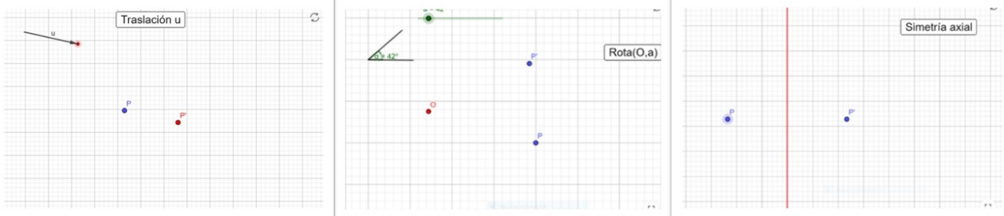

Figure 2: Images of the applets created to show fixed points of translation, rotation and reflection

Finally, questions will be raised that allow students to achieve: Is the reciprocal result true? If a movement is an isometry which has no fixed points, must it be a translation? What if you have a single fixed point? What if you have infinities?

### **Assignment 3**: Composition of isometries

Learning objective: This activity shows what happens when we compose some of the isometries. Through the visualization, students should come up with some results about composition of isometries. These theorical results they should deduce lead to the demonstration of the theorem of isometries classification. This activity is divided into three applets:

* Composition of a rotation and a translation.
* Composition of a reflection and a rotation which center belongs to the reflection line.
* Composition of a reflection and a translation.

Student activity:   
Students have to follow some steps given and get to the following conclusions:

* Rotation and translation: Students should conclude that the composition of a rotation with a certain angle and a translation is always equivalent to a rotation of the same angle. In a deeper analysis, by manipulating the points, they should be able to deduce how the center of the new rotation is obtained. The students have to answer some questions about the applet which will lead them to this conclusion.
* Reflection and rotation: Students should conclude that the composition of a reflection and a rotation whose center belongs to the reflection line, is always equivalent to another reflection. In a deeper analysis, by manipulating the points students should be able to deduce how the axis of the new reflection is obtained.
* There are two different cases for this composition: the vector v of the translation can be perpendicular to the line of reflection, or not. Students should realize the difference between both cases and conclude that the composition of these two isometries will be a new reflection if the translation vector v is perpendicular to the line of reflection. Otherwise, the composition will be a glide reflection. Students should also be able to deduce that the vector u of the glide reflection matches with the component of v parallel to the line of reflection.

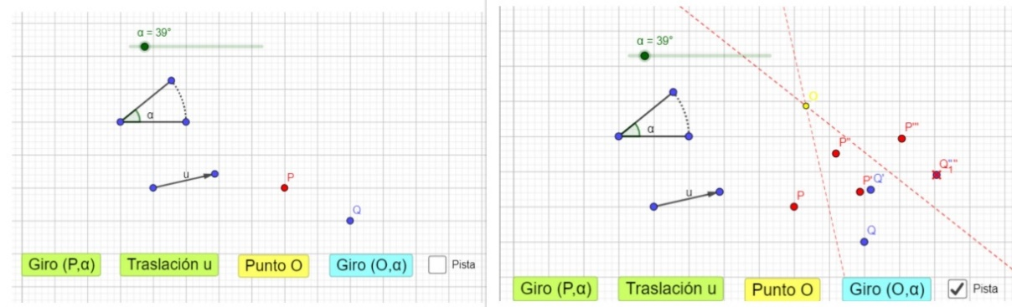

Figure 3: Applet created for the composition of a rotation and a translation. Left, the initial screen of the applet, right the applet when all the steps have been followed

### **Assignment 4**: Tessellations of the plane

Learning objective:

The main objectives of these activities are:

* Visualization and identification of the elements involved in the generation of each crystallographic group. Knowledge of the the mathematical concepts related to tilings like fundamental domain, unit cell or generator system.
* Understanding the tile construction technique that Escher used in his designs: these tiles can acquire many shapes, maintaining the constant area and considering for the construction of these tiles the isometries involved in the generation of each group.
* Be able to generate with each crystallographic group a tessellation of the plane, making use of the generation of tiles technique learned.

Student activity:   
This assignment consists of 18 GeoGebra applets:

* In the first three applets, students will visualize in a very detailed way how two of Escher’s tiles are created and they are asked some questions about what they have seen in order to make them think about concepts as fundamental domain and unit cell.

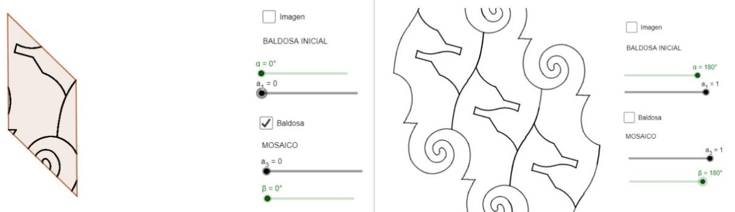

Figure 4: Shows the initial and the final screen for the activity designed to show tile construction for chrystallographic group p2

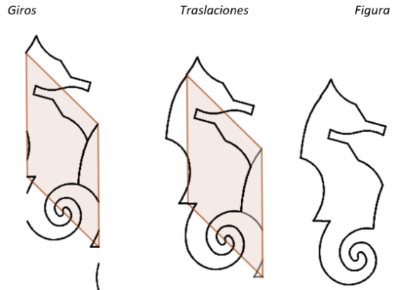

Figure 5: Moving the first slider we can see how the archs moved by a rotation move to their final position. Moving the second slider we see the archs moved by a translation moving to their final position. On the right, the final tile for the design.

* In 13 of these applets students are asked to identify the isometries of the plane involved in both the creation of the unit cell and the tiling. They have to identify the elements involved and they are asked some mathematic questions about the particular Escher’s design shown in the applet. They are expected to use the proper mathematical vocabulary to describe the isometries involved and their elements. They are also encouraged to create their own tiling using the ideas they have learned about each group and Escher’s creating tiles technique.

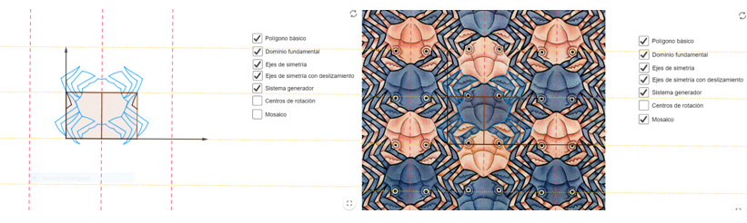

Figure 6: Images of the applet created for crystallographic group pmg

* The two activities left are quite different to the previous. In these activities students have to create the tessellation using the GeoGebra toolbar. In the applet, all the elements involved in the creation of these tiling are given to the student: fundamental domain, reflection axes, rotation centres, translation vectors… These activities are intended for the student to both learn to use the GeoGebra basic tools for plane transformation and also to visualize in a very detailed way how these patterns are created.

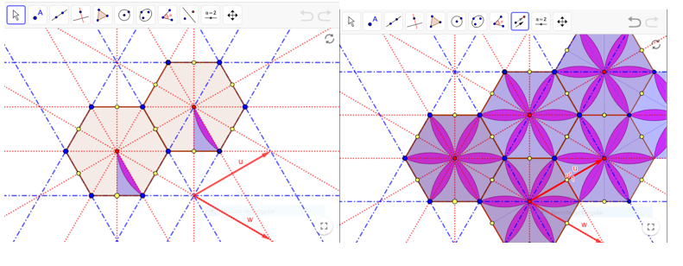

Figure 7: Image of the applet created for crystallographic group p6m

## Suggestions for use

The two parts, isometries and tessellations, can be used separately.

Lecturers can consider interactive discussions in the classroom with their students about their results of assignment 4 and in particular about their designs of computer experiments.

## References

Coxeter, H.M.S. (1988). Fundamentos de Geometría. Ed. Limusa S.A.

Gómez-Chacón, I. Mª y Kuzniak, A. (2015). Geometric Work Spaces: Figural, instrumental and discursive geneses of reasoning in a technological environment, *International Journal of Science and Mathematics Education*, 13 (1), 201-226

Gómez-Chacón, I. M., Romero, I. M. y García, M. M. (2016). Zig-zagging in geometrical reasoning in technological collaborative environments: a Mathematical Working Space-framed study concerning cognition and affect, *ZDM-The International Journal on Mathematics Education*, 48(6), 909-924.

Hilden, H., Montesinos, J.M., Tejada, D. Toro, M. (2012). Impresión de diseños simétricos en la obra de Escher. Tecné, episteme y didaxis: revista de la Facultad de Ciencia y Tecnología, (32), 105-123

Sáiz, E. (2020). Generation of mosaics and tessellations: Crystallographic groups. Practical examples for teaching at university level from Dynamic Geometry. Final Degree Project, Mathematics Degree at the Faculty of Mathematics of the Complutense University of Madrid; directed by Inés María Gómez Chacón. (In Spanish Language).

Schattschneider, D. (2010). The mathematical side of M.C. Escher. Notices of the AMS, 6, 57, 706-717.