Teaching unit Multivariate calculus

Course:
Mathematics 2 (8 ECTS credits, 1st year graduate students , 3 groups of 20-25 students), week 4

Aim:
To foster mathematical and geometric intuition for understanding basic concepts of multivariate calculus (contour plot, partial derivatives, stationary points, extreme points, etc.)

Activity 1: The revision of the basic terms (contour plot, partial derivatives)
Answer the questions 1, 2 of the quiz on Classroom voting system Socrative (room BE483461)

Problem 1:
The figure depicts the contours of the function z=f(x,y). Find the solution of the equation f(x,5)=3.

Problem 2:
Suppose that the function z=f(x,y) has both partial derivatives in the point K=[3,2]. Try to determine their signs.
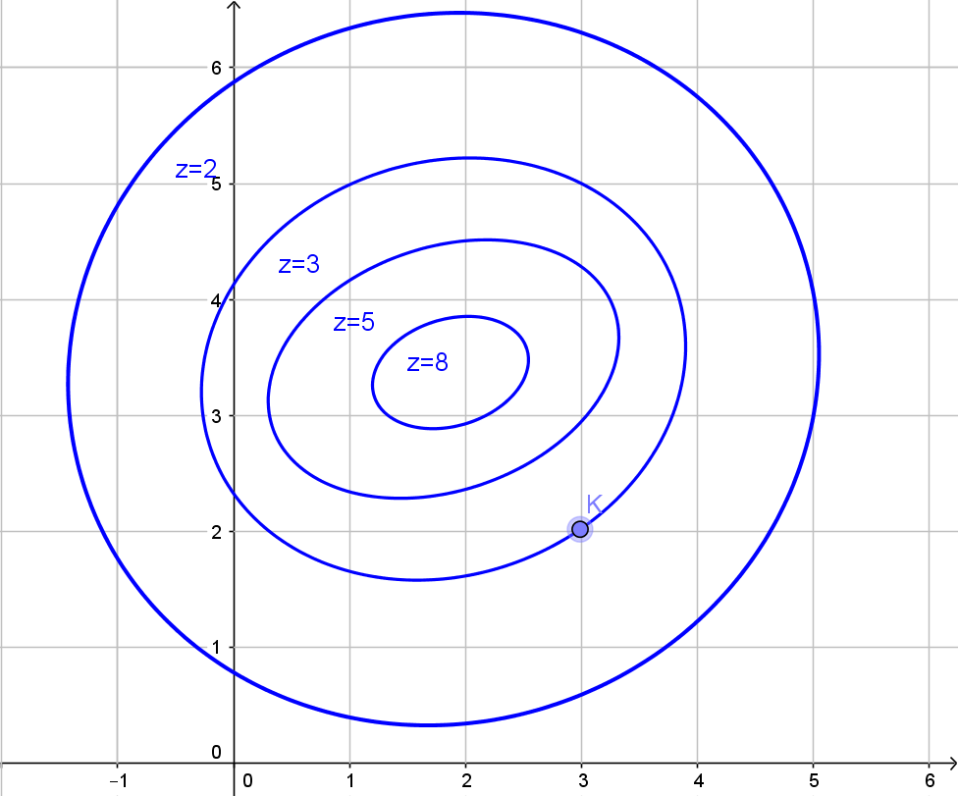

Activity 2: Multivariate optimization
Solve the problems 1-3 in groups of three or four (1 handout for each group). Completing the tasks is followed by the discussion.

Problem 1:
Find the lowest and the highest point on the path from C to D
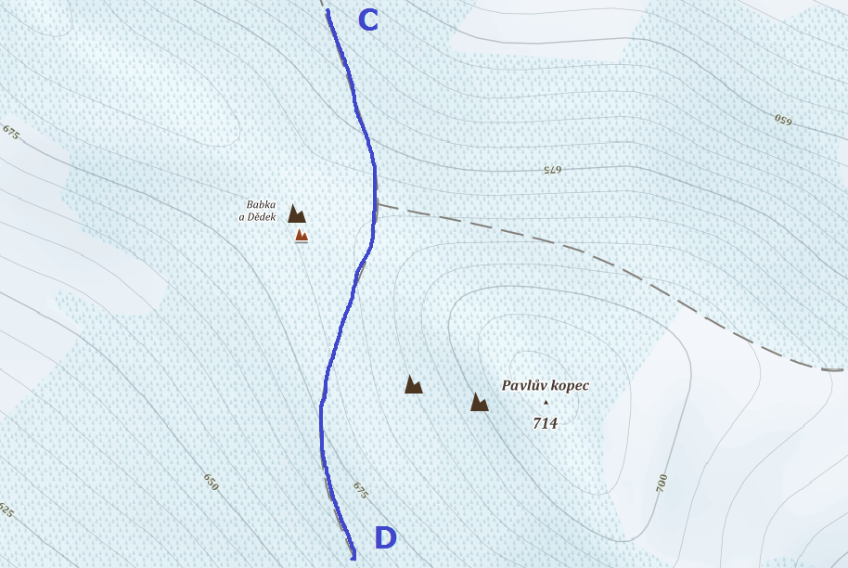

Problem 2:
Find the lowest and the highest point on the path from A to B

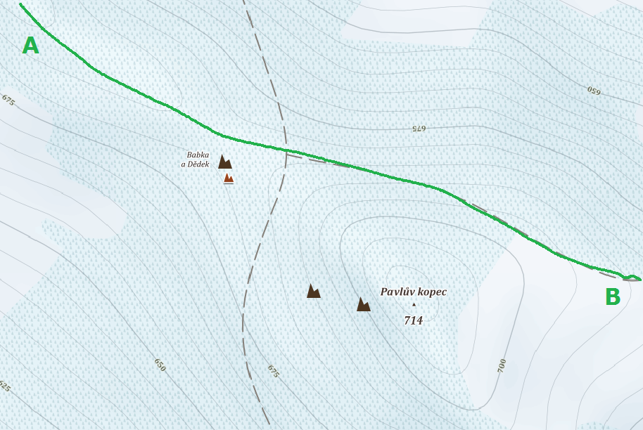
Supplementary questions:
- can you see any extrema points on the map?
- describe the relation betweeen the density of contours and „the steepness of the surface“.
- why is the highest place on the path CD and the lowest place on AB represented by the same point?
- can you identify a saddle point on the map?

Problem 3:
Find the lowest and the highest point in the selected region.
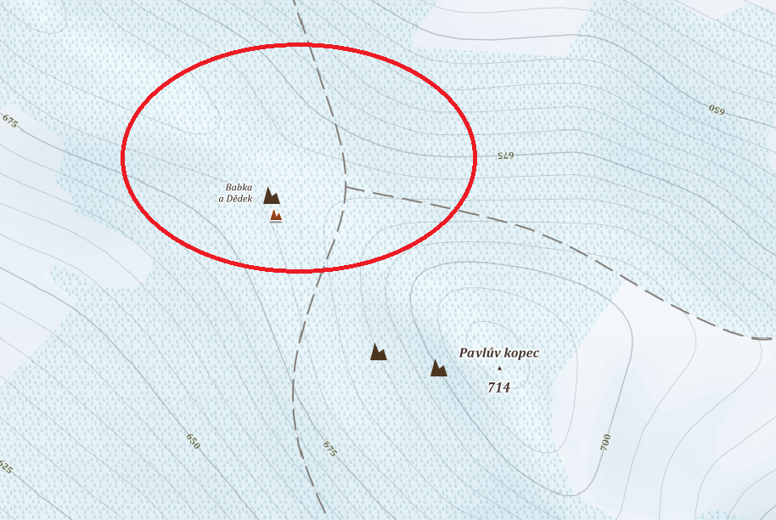
Supplementary questions:
- does the maximum lie inside the region or on the boundary?
- does the minimum lie inside the region or on the boundary?
- are both partial derivatives equal to zero in the extrema points?
- try to characterize the possible locations of extrema points .

