Introductory Mathematics -Functions: Including Inverse and Trigonometric Functions
Paola Iannone, Barbara Jaworski, & Stephanie Thomas; Loughborough University

A. Information for lecturers

Context
These tasks were designed explicitly for a cohort of students in Materials Engineering by a teaching-research team of four colleagues: two were very experienced in teaching mathematics for engineering students, one was experienced in inquiry-based teaching and learning in mathematics and the fourth was a research associate who supported the activity. The project (ESUM: Engineering Students Understanding Mathematics) was supported financially by the UK HE-STEM programme.
Experience of teaching several cohorts of these students (each of approximately 50 students) showed that many students had not had suitable prior experience in their learning of mathematics to enable their understanding of university-level concepts. We believed it was necessary for a first course in university mathematics to provide experience of engaging with basic mathematical concepts in ways that stimulated their understanding.
The course (or module, as courses were called) was taught over one semester by a lecturer who was one member of the team of four. Material for the teaching and for students’ collaborative activity was designed together by members of the team, with support from two graduate students. For students’ reference, we provided a set of booklets, specially designed for the learning of mathematics in such modules, referred to as the HELM books: Helping Engineers Learn Mathematics. The module was allocated, per week, 2 lectures and one tutorial (each of 50 minutes). Lectures were held in a traditional tiered lecture room; at our request, the tutorial was situated in a computer lab with sufficient computers for the whole cohort. In tutorials, students worked in groups of four on tasks supplied by the lecturer; each group of four had a set of four computers located together, with access to GeoGebra. The expectation was that in any group, students could work freely at one or more computers and that they would discuss the task, work on it together or separately, and reach a shared outcome. The lecturer and one graduate student circulated, encouraging the groups in their joint activity, asking questions, encouraging students’ own questions and generally fostering an inquiry mode of engagement.
The research associate attended all lectures and tutorials, audio-recording and making notes of activity for future discussion in the team. After each session the lecturer and researcher talked together reflecting on the event and noting aspects and issues for further consideration. This allowed the lecturer to recognise aspects of the lecture or tutorial that worked well and/or raised issues and to adjust future teaching activity if this seems appropriate. Data from notes, recordings and reflections became material for future analysis.

Special Needs
The university provides a special centre, the Mathematics Learning Support Centre, for students who find difficulties with their study of mathematics in first-year modules in any areas of study. Students could drop in at any time during opening hours and be given one to one support from a tutor or lecturer on duty. In the ESUM project, both lectures and tutorials were designed to include students in mathematics, responding to the lecturer’s questions and engaging with their peers. This allowed the lecturer to notice students who seemed to need additional support and to provide support as appropriate.

Aims
The aims of the project were to engage students with inquiry-based tasks in basic mathematics, in a collaborative environment that would foster their mathematical understanding. The approaches to achieving these aims have been described above.

The tasks
For each topic of the module a task sheet was written including a set of tasks designed to achieve students’ inquiry into mathematical concepts and to foster their understanding. Tasks were designed specifically to encourage peer collaboration with suggestions for students’ activity with the tasks. Here we provide two examples: one focusing on inverse functions and one on trigonometric functions, together with associated teaching notes. Teachers/lecturers might follow the style of these units in designing other inquiry-based tasks for their mathematical topics.

Assessment
The module which took place in the first semester of the academic year was followed by a continuation module in the second semester. Work in both semesters was examined in a final exam which was traditional in style. An aim of ESUM was to separate the assessment for the two semesters so as to allow an examination more related to the ESUM aims and style. At the time of ESUM, this was not achieved. So, because we know that assessment is important for students, the continuous assessment during the module included a group task through which each whole group worked together on given inquiry-based questions and wrote a joint project report which was assessed. This achieved our aim of motivating students to engage in the inquiry-based tasks. The reports were submitted by all groups and all achieved a reasonable grade, some a very good grade.
The two areas of tasks included here involve Inverse Functions and Trigonometric Functions. In each case, what you see written is what was given to each group of students.

Learning activity

Tasks relating to Inverse Functions

These are questions given to students in a tutorial on inverse functions where inverse functions have been discussed in a lecture. Students are first year engineering students, many of whom do not have mathematics at Advanced level.
The class of 50 students was divided into groups of 4 who were asked to work together in a computer room to explore the mathematics in the questions. They are asked to use the computer software GeoGebra.

Discuss all of these questions in your group and try to agree on your answers. You might like to share out the questions, tackle some of them individually and then share your findings. Complete the unfinished questions later in your own time.
1.
a) Taking the domain as the entire set of real numbers (the whole of the x-axis) draw graphs of the following mapping rules in GeoGebra.
b) Inspect your graph and decide on the image set (range) of the mapping.
c) Move a vertical and horizontal line across the graph and determine if you have a one-one function, a many-one function, or a one-many mapping. Hence decide if the mapping is a function and if it has an inverse.

- x 2x – 3
- x 5x + 1
- x 3 - 2x
- x 3x2
- x 2 – 3x2
- x 3x2 + 5x – 2
- x 2(x+3)2
- x (2-x)(x+3)
- x x3
- x 3x3 + 2x2 - 7x + 2
- x 2(x-1)3
- x x(x-1)(x+1)
- x √x and x.. -√x **
- x √(x-3) and x -√(x-3)
- x √(3-x2) and x -√(3-x2)
- x √(4+x2) and x -√(4+x2)
**Here you have to use sqrt in GeoGebra – find it in a menu bottom right.

For the functions which do not have an inverse, explain why not and how you might restrict the domain of the function so that an inverse is possible. Discuss this with your tutor if you are not sure.

2.
For some of the mappings in Question 1 above (you choose which ones to explore), in GeoGebra, reflect the graph in the line y=x and explain what you observe. (Use the 9th small menu at the top to find a reflection command).
Agree in your group and write down a concise statement connecting the graph of the inverse of a function with the strategy you have used above.

3.
Enter the following to GeoGebra and discuss, describe and explain what you get:
a) y2 + x2 = 4 b) (y-1)2 = 1 – (x+2)2 c) (x/2)2 +(y/3)2 = 1
You may find it helpful to read section 2.6 in HELM 2.

4.
Which of the graphs below represents the inverse of the function graphed in Figure1? Discuss first in your group, then try to draw something similar in GeoGebra to confirm what you think. (You can use the If command to restrict the domain – ask for help to do this).
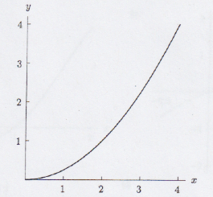Figure1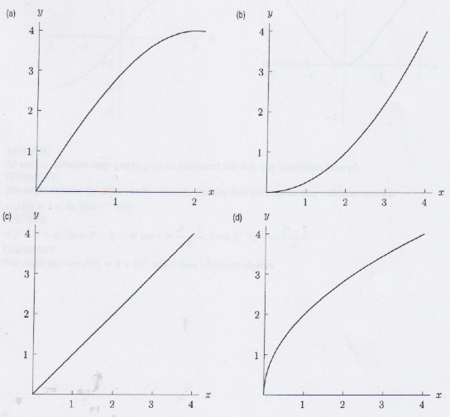

5.
Which of the following could be graphs of functions that have an inverse? Discuss and explain. (Think about a horizontal line passing across the graph.)
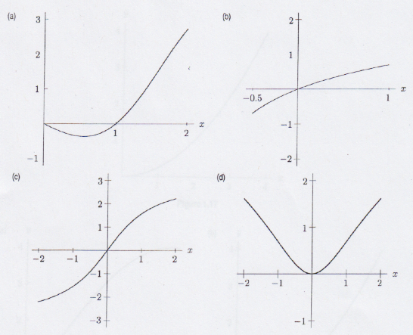

6.
For all real x, let the functions f, g, and h be defined, on the domain of all real numbers, as follows:
f(x) = (x³/3) + (x²/2) + x + 1
g(x) = x³ + x² + x + 1
h(x) = (x³/3) + (5x²/2) + 6x + 1
Which of these functions has an inverse? How might you restrict the domain for those which do not, in order to have an inverse?

7.
Graphically, restrict the domain on the following functions and then find an inverse for the function on the restricted domain
- y=(x-1)(x+3)
- y=x(x-1)(x+3)
How can we work out the inverses algebraically?
[This is a harder question.]

Tasks relating to Graphs of Trigonometric Functions and

Using graphs to find solutions to Trigonometric Equations
These are questions given to students in a tutorial on trigonometric functions where trigonometric functions have been discussed in a lecture. Students are first year engineering students, many of whom do not have mathematics at Advanced level.
The class of 50 students is divided into groups of 4 who are asked to work together in a computer room to explore the mathematics in the questions. They are to use the computer software GeoGebra.

1.
As a group, use GeoGebra to explore the following trigonometric functions. You will need to enter parameters a, b, c, d as sliders before using them in functions.
bsin(ax+c); bsin(ax) + c; bcos(ax+c)+d; btan(ax+c); btan(ax+c) + d;
You need to be clear as to how varying a, b, c and d affects the basic function sin, cos or tan.
As a result of the above exploration, you should now have a good understanding of these functions and you should be able to sketch by hand such a function if asked to do so in a test or exam.

2.
Work with members of your group on the following and discuss what you find.
For the equations below, solve the equation analytically using the inverse sin, cos or tan and your calculator. Then draw a suitable graph and use it to find a solution or solutions to the equation (do this for different domains where the relevant graph is one-one). See if your findings from the two methods agree.
a) sin 2x = 0.5
(Hint – draw graphs of y=sin 2x and y=0.5 and inspect point(s) of intersection.)
b) 3sin 2x = 1 c) tan (2x – 1) = 5 d) sin (3 – x) +4 = 5
e) 2 – cos 5x = 3 f) 2 – cos 5x = 7 g) 0.1tan (0.1x) = -3
3.

Together with others in your group, work on the following questions related to trigonometric expressions and equations: you can find the trig identities in HELM 4 and in the example sheets
a) Write 15, 30 and 45 degrees in terms of
and hence find cos 15 using cos (45- 30) and an appropriate trig identity.
b) Use trig identities to show that: [sin (a – b)]/[sin a sin b] = cot b – cot a
c) Show that: sin 3x + cos 3x = 4 cos 2x
sin x cos x
d) Prove the identity: sec (a/2) + cosec (a/2) = 2[sin(a/2) + cos (a/2)]/sin a
e) Solve the equation: 2cos² x – sin x - 1 = 0 (0 x < 2)
f) Solve the equation: sin 2x +sin x = 0 (- x < )

A condition of the funding was that documentation of the project should be available in open access via Creative Commons. Findings from our research in the project were published in several papers, two of which are Jaworski & Matthews, 2011; Jaworski, Robinson, Matthews and Croft, 2012.
Accessible at https://www.lboro.ac.uk/departments/mlsc/student-resources/helm-workbooks/
See Chapter 4 of the PLATINUM book.
For an introduction to the theory of inquiry in the PLATINUM project please see the PLATINUM book, https://doi.org/10.5817/CZ.MUNI.M210-9983-2021, particularly Chapters 2 and 16.
Example sheets contain relevant processes and formulae created by the lecturer.

