Complex Numbers
Paola Iannone, Barbara Jaworski, & Stephanie Thomas ; Loughborough University

A. Information for lecturers

Context
Complex numbers (CN) are taught in a Foundation mathematics module which is part of the Foundation Studies Programme at our university. The Foundation year is a one-year long course, sometimes referred to as a 'Year 0', and a preparation year for Engineering and Science students who wish to progress to the first year of a (STEM) degree. For our university, the reason for taking a Foundation year is mostly related to a lack of an appropriate prior qualification, often a mathematics or physics A-level. Although these tasks were used with Foundation students, they could also be used with a first year Engineering cohort.

Students enrolled on this module have a varied mathematical background - typically GCSE grade C as highest mathematical qualification to A level grade A. The Foundation year spans two semesters, each with twelve weeks of teaching and three weeks set aside for assessment (across all the courses taken). Foundation students are enrolled on four courses each semester (at our university we call them modules); mathematics is taught in both semesters and is compulsory for all. The following topics are taught in the mathematics foundation module:

Algebra, Logarithms, Inequalities, Functions, Trigonometry, Vectors, Differentiation, Integration, Sequences and Series in Semester 1 (October to January) and Polynomials, Partial Fractions, Further Calculus, Conic Sections, Vectors, Matrices, Complex Numbers in Semester 2 (February to June).

Aims
The tasks were designed in collaboration with first-year Engineering students who had completed the Foundation Studies Programme in the previous year. We refer to the students who were involved in the designing of the tasks as 'Student-Partners' (see Chapter 15 on Case studies from LU). The focus of the tasks is the arithmetic operations on CNs, a topic which is typically introduced algebraically. Using dynamic software, the aim of using the CN tasks is to provide geometric insights that complement an algebraic approach of presenting CNs. Seeing geometry and algebra as fundamental to all mathematics (Atiyah, 2001) we also wish to make this connection explicitly in teaching and learning. From the research literature we know that providing geometric insights has been shown to potentially both help and hinder, (Gueudet-Chartier, 2004). However, we align ourselves with research into geometric representations as a means of connecting with students’ more intuitive understanding of a concept or notion (Stewart & Thomas, 2009; Uhlig, 2003).

The tasks
There are six CN tasks on a 'hand-out', that is written instructions for students. In addition, students access six interactive Computer files embedded in the software Autograph. All six tasks were designed to be used in a single session (in a Computer lab) of 50 minutes - forming part of students' workshop or tutorial provision). The six tasks are:
- Addition of two CNs
- Subtraction of two CNs
- Multiplying together two complex numbers
- Multiplying a complex number and its complex conjugate
- Raising a complex number to the power 2 (i.e. squaring)
- Raising a complex number to the power 3 (i.e. cubing)
The tasks were used in Semester 2 in week 8 and after the formal introduction of CNs in the lecture. Students could choose to work in pairs or on their own. While some chose to work with a peer, most students (over the three years of trialling the tasks) worked on their own.

Learning activity
One way to design a CN task on addition could be: Given z₁ and z₂, find z₁+z₂ and use Autograph to check that your answer is correct. This kind of question mirrors the way many exercises are designed in mathematics textbooks (and are important in their own right). The CN tasks presented here were designed to allow students to explore concepts without focussing on 'correct' answers. Hence, this particular (addition) question was 'reversed' to ask "Given z₁, what is z₂, in order that z=a+bi?" (with a and b specified). 'Addition' is not mentioned and comes out of the working on the task as is linking addition of CNs to the 'triangle law' or 'parallelogram law' - the geometric representation.
Two tasks including the addition task are described in more detail below. As the Foundation Studies Programme at our university leads to most students entering Engineering degrees, the Engineering convention of using the letter j (in place of i) was adopted.

Lecturer experience of using the tasks
The students worked on the problems without any significant difficulties. It seems that they found it relatively easy to follow the instructions on the 'hand-out'. Questions raised at the beginning of the session centred mostly on how to access the computer files.
Questions raised by students while working on some of the tasks often centred on the meaning of geometry or geometric. Although used by the teacher in the lecture, it seems that students were not very familiar with geometric notions which may be a result of a lack of teaching of geometry at school level.
In addition, there were comments by some students that the instructions were too long or "too wordy". This raises an important point in relation to special needs provision, in particular provision for dyslexic students who may find long instructions difficult to follow and unmotivating. The teacher of the course made the decision to shorten the tasks and to keep instructions to a minimum. Hence, the current version is a remake of the original design.
[Additional note: While the computer files run on Autograph only, it is possible to re-design them for use on GeoGebra (a free software).]

Special Needs
None of the tasks have been modified for use by students identified with a special or additional need. The tasks are carried out on a computer and may be problematic to access for sensory impaired students. However, teaching could be structured in such a way that all students work in pairs which may be more inclusive of all students.

Assessment
There is no assessment linked to the tasks. This is a problem if the (local) student culture is such that work - which will not formally be assessed - is ignored or not taken seriously. Engagement with the task in tutorials was comparable with engagement in tutorials more generally during the year. However, some informal comments received from students did relate to questions of the kind "Will this be in our exam?" Hence, one brief conceptual type question was included on the final examination paper and generally answered correctly by students.

B. Student learning activities
Worksheets and Autograph files (source files and screenshots) are provided separately. As examples I present two tasks of the six tasks that were used with students: Task 1 on the addition of CNs and Task 4 on multiplying a complex number and its complex conjugate.
Task 1 - Addition
Written instruction for students in the tutorial:
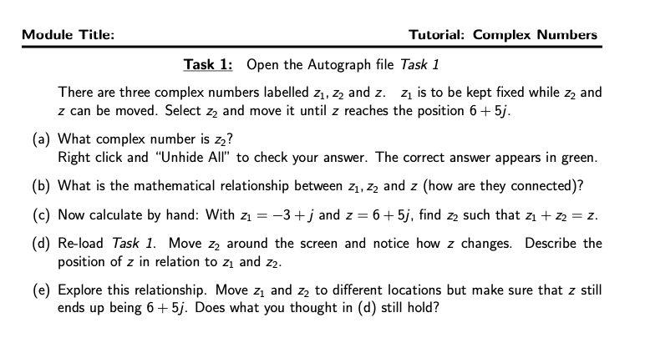
Screenshot of Autograph file that students can access on the University server:
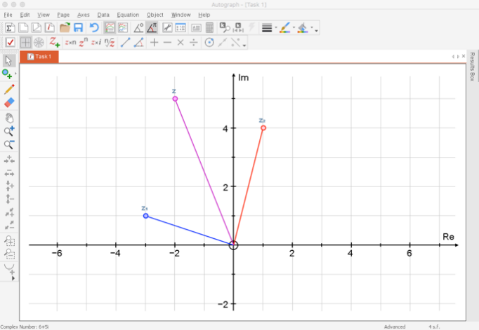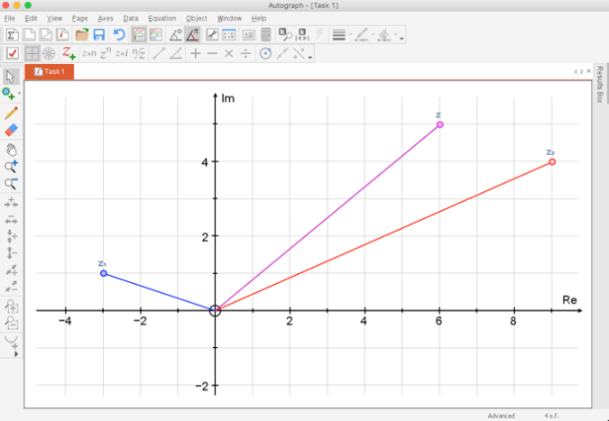
Task 1 Task 1 with z₂ moved
In this task three complex numbers are displayed on the screen, z₁, z₂ and z where z is equal to z₁+z₂ (see Task 1). The instructions state to keep z₁ fixed and to move z₂ until z reaches a specified position, here 6+5j (see Task 1 with z₂ moved). As z₂ is moved, the linked object z₁+z₂ moves dynamically with it. Students have to determine z₂ and determine the (arithmetic) relationship between z₁ and z₂ (addition) and its geometric representation (parallelogram law or triangle law). Students follow the instructions on the hand-out and explore the geometric representation with other values for both z₂ and z.
The inquiry element comes from being able to use the software to explore addition without performing any calculations.

Task 4 - Complex conjugate
Written instruction for students in the tutorial:
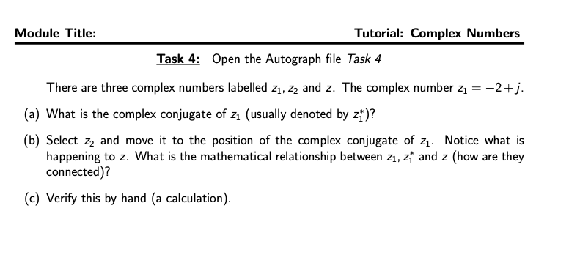
Screenshot of Autograph file that students access on the University server:
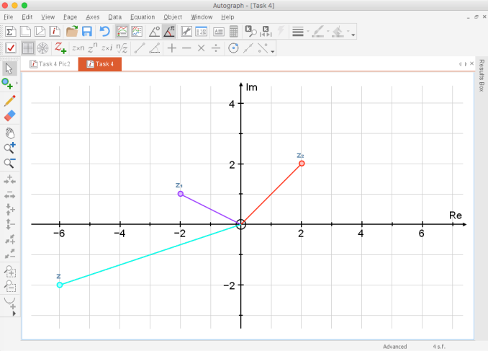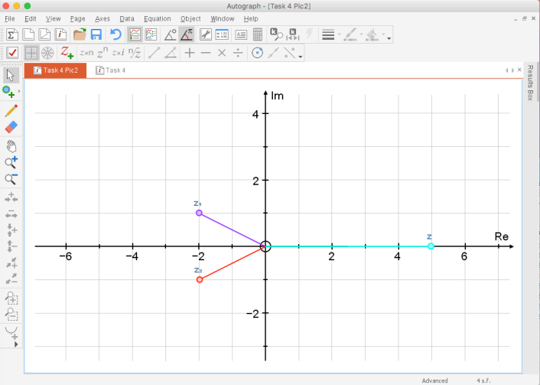
Task 4 Task 4 with z₂ moved

In this task three complex numbers are displayed on the screen, z₁, z₂ and z where z is equal to z₁z₂ (see Task 4). In the task students observe what happens to z when z₂ is moved into the position of the complex conjugate of z₁ (see Task 4 with z₂ moved). In this task no reference is made to any numerical value for z₁ or for z₂, or their product. This task has a very different character to Task 1. It is more general and almost invites exploration.
Using the polar grid representation instead of Cartesian axes (possible in Autograph) would show the angles and to recognising that they cancel out – one angle taking a positive value while the other (while equal in size) is negative. In a follow-up one of the student-partners commented on this task and the potential for deeper understanding, saying that while many students may know that the multiplication of a complex number and its complex conjugate results in a real number, they - as partners in the design of this task – knew ‘why’ that was the case.

Atiyah, M. (2001) Mathematics in the 20th century: Geometry versus algebra, Mathematics Today, 37(2), 46–53.
Gueudet-Chartier, G. (2004). Should we teach linear algebra through geometry? Linear Algebra and Its Applications, 379, 491–501.
Stewart, S. & Thomas, M. O. J. (2009). A framework for mathematical thinking: The case of linear algebra. International Journal of Mathematical Education in Science and Technology, 40(7), 951–961.
Uhlig, F. (2003). Author’s response to the comments on ‘The Role of Proof in Comprehending and Teaching Elementary Linear Algebra’. Educational Studies in Mathematics, 53(3), 271–274.

These are UK qualifications. A GCSE grade C is an average grade for a student leaving compulsory formal education (typically aged 16); an A-level grade A (now newly introduced A*) is the highest grade for a student leaving post-compulsory (16-18) education (typically aged 18).
Example of question on the final examination: Explain the effect on magnitude and argument when a complex number is (i) squared, (ii) cubed.

