MAA309 Tutorial: Inverse functions
These are questions given to students in a tutorial on inverse functions where inverse functions have been discussed in a lecture. Students are first year engineering students, many of whom do not have mathematics at Advanced level.
The class of 50 students is divided into groups of 4 who are asked to work together in a computer room to explore the mathematics in the questions. They are to use the computer software GeoGebra.
Discuss all of these questions in your group and try to agree on your answers. You might like to share out the questions, tackle some of them individually and then share your findings. Complete the unfinished questions later in your own time.
1.
a) Taking the domain as the entire set of real numbers (the whole of the x-axis) draw graphs of the following mapping rules in GeoGebra.
b) Inspect your graph and decide on the image set (range) of the mapping.
c) Move a vertical and horizontal line across the graph and determine if you have a one-one function, a many-one function, or a one-many mapping. Hence decide if the mapping is a function and if it has an inverse..
- x 2x – 3
- x 5x + 1
- x 3 - 2x
- x 3x2
- x 2 – 3x2
- x 3x2 + 5x – 2
- x 2(x+3)2
- x (2-x)(x+3)
- x x3
- x 3x3 + 2x2 - 7x + 2
- x 2(x-1)3
- x x(x-1)(x+1)
- x.. √x and x.. -√x **
- x √(x-3) and x -√(x-3)
- x √(3-x2) and x -√(3-x2)
- x √(4+x2) and x -√(4+x2)
**Here you have to use sqrt in GeoGebra – find it in a menu bottom right.

For the functions which do not have an inverse, explain why not and how you might restrict the domain of the function so that an inverse is possible. Discuss this with BJ or SB if not sure

2.
For some of the mappings in Question 1 above (you choose which ones to explore), in GeoGebra, reflect the graph in the line y=x and explain what you observe. (Use the 9th small menu at the top to find a reflection command).
Agree in your group and write down a concise statement connecting the graph of the inverse of a function with the strategy you have used above.

3.
Enter the following to GeoGebra and discuss, describe and explain what you get:
a) y2 + x2 = 4 b) (y-1)2 = 1 – (x+2)2 c) (x/2)2 +(y/3)2 = 1
Relate what you have found to section 2.6 in HELM 2.

4.
Which of the graphs over the page represents the inverse of the function graphed in Figure1? Discuss first in your group, then try to draw something similar in GeoGebra to confirm what you think. (You can use the If command to restrict the domain – ask for help to do this).
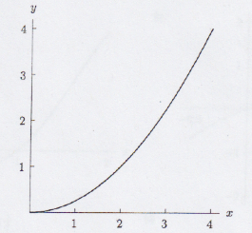Figure1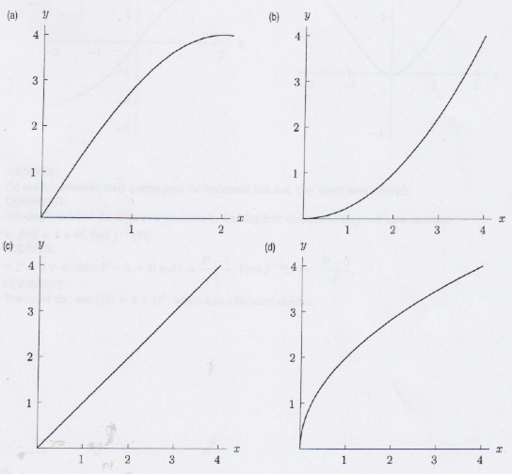

5.
Which of the following could be graphs of functions that have an inverse? Discuss and explain. (Think about a horizontal line passing across the graph.)
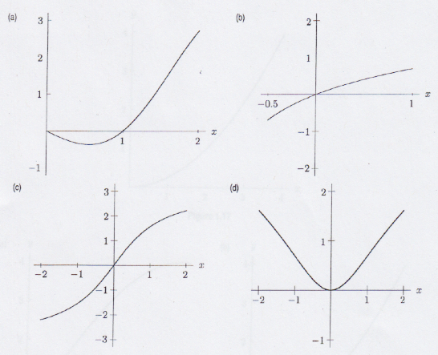

6.
For all real x, let the functions f, g, and h be defined, on the domain of all real numbers, as follows:
f(x) = (x³/3) + (x²/2) + x + 1
g(x) = x³ + x² + x + 1
h(x) = (x³/3) + (5x²/2) + 6x + 1
Which of these functions has an inverse? How might you restrict the domain for those which do not, in order to have an inverse?

7.
Graphically, restrict the domain on the following functions and then find an inverse for the function on the restricted domain
- y=(x-1)(x+3)
- y=x(x-1)(x+3)
How can we work out the inverses algebraically?
[This is a harder question.]

