Exercise, as implemented digitally in Summer 2020
Limits of curve sketching in school?
A fictional scenario
Introduction:
An upper high school class reviews the topic of inflection point. One pupil draws on the sheet of his desk neighbor graph 1 below and comments:
“Yo, I always wondered: if a function looks like this, does it have inflection points on the entire straight segment?”
The desk neighbor, visibly amused, adds graph 2 below and replies:
“Look! Can’t you do the same with a parabola? If you flatten it on the bottom, like this, wouldn’t you also have lots of extremums? Infinitely many even!”
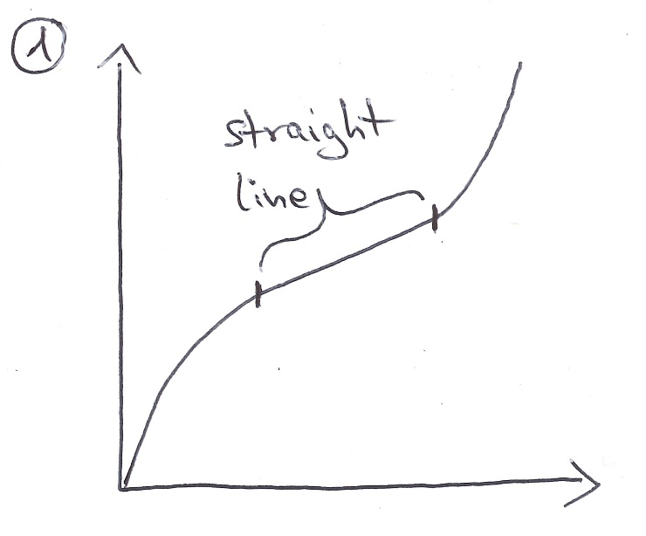
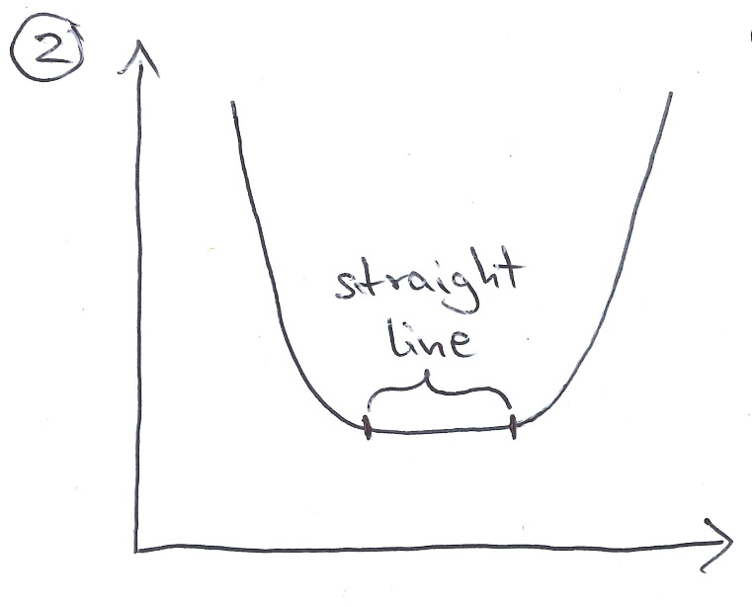

Points of interest
In the introductory scenario, the following two questions are raised:
- How many inflection points does graph 1 have?
- How many extrema does graph 2 have?
Your job will first be, to find a mathematical answer to these questions. Theoretically, the required information should be contained in the excerpt from a German schoolbook we provide as download below. You are allowed, however, to consult other sources as you please.
[Download button for the textbook excerpt:
Freudigmann, H., Buck, H., Greulich, D., Sandmann, R., & Zinser, M. (2012). Lambacher Schweizer – Mathematik für Gymnasien. Analysis Leistungskurs. Stuttgart: Ernst Klett Verlag. 38–67]
If you subsequently wonder, how a teacher could respond to the two given questions in class, it is necessary to analyze the mathematical subject matter more thoroughly and to assess, what connections exist between the two questions and school mathematics and whether the questions might brush on elements of mathematical knowledge which are not typically found in upper high school curricula. Your lectures of Analysis should provide solid background knowledge for this activity.
Hint for the inquiry into the two mathematical questions above: The “straight lines” in the sketches are not intended to be “seemingly straight lines”, which are in reality curved like regular polynomials. Instead, the two graphs are intended to have truly straight segments.

Learning goals for this topic
Minimal learning goal:
a) You should know a mathematical definition of the terms "extreme point" and " inflection point" (for example those from the textbook excerpt provided).
b) You should be able to answer the following questions correctly on a mathematical level:
- How many inflection points does Graph 1 have?
- How many extrema does Graph 2 have?
Advanced learning goal:
You are able to make a reasoned suggestion for a teaching approach that reacts to the proposed fictional scenario and aims to bring up and clarify mathematical questions 1 and 2.

Task instruction:
I) Development of teaching material
Create learning material for your fellow students that supports them in achieving a learning goal of your choice that is connected to the given topic [here: the above described fictional scenario and the questions it raises]. The learning goal can either be one of the two goals we have set (minimal or advanced) or a learning goal you have chosen yourself. The material you create should complement the material provided by us in a meaningful way and it should be possible for learners to work with it independently (i.e. without the help of a teacher).
II) Essay on the topic
Write an essay in which you first give sufficiently detailed answers to the following mathematical questions:
- How many inflection points does graph 1 have?
- How many extrema does graph 2 have?
You have to make clear, how you arrived at your answers, i.e. how the answers are mathematically justified.
Please explain afterwards didactical peculiarities of questions 1) and 2) that you noticed when you worked on them. In doing this, focus on the following questions:
- In what way do questions 1) and 2) go beyond typical school mathematics?
- At what point could a high-school student who works on these questions encounter unexpected difficulties or “unchartered terrain”?
- What knowledge is necessary to overcome eventual difficulties?
Finish by making a reasoned suggestion on how a teacher could react to the thoughts contained in the above interaction between two high-school students in class (i.e. to questions 1) and 2))? What topics could be revisited with the class in connection with / in response to the questions?

