Introduction to Definite Integral
  - Zuzana Pátíková; Brno University of Technology

A. Information for lecturers

Unit description
Description: The main aim of the lesson is to introduce the concept of the definite integral and its geometric interpretation to bachelor students of technical study programs in their 1st year of studies. The activities start with a warm-up consisting in recalling the concept of area of a planar polygonal shape. The idea of finding area of a general non-polygonal shape leads to introduction of the upper and the lower (Riemann) sum and corresponding limits.. Students work with visualization of these notions using mobile devices within a ready-to-use interactive application. After introducing the notion of definite integral and Newton-Leibniz formula, first simple examples of definite integrals are calculated, immediately illustrated, and interpreted in pictures of graphs of the integrated functions.
Student and discipline level: 1st year bachelor students of technical/engineering study programs
Prior knowledge: Expected student and lecturer knowledge and skills are
- indefinite integration and related manipulations with expressions
- sketching graphs of elementary functions
- notion of a function and a derivative of a function
- idea of a limit process
- calculating area of basic shapes

Estimated duration: 100 min

Facilities: tablets (mobile devices)

Learning objectives
At completion of the unit, students will be able to
- talk about and work with the concept of definite integral
- understand why one would be interested in a definite integral and that it is an effective tool for calculating areas
- understand how the outcome of definite integration is dependent on the sign of the function
- compute numerically definite integrals with use of Newton-Leibniz formula
- compute numerically area below the graph of a function and illustrate the result in a picture
- think more critically about what comes as an outcome of definite integration
- explore and formulate ideas about areas of shapes and definite integration in collaboration with peers, verify and present findings to others

IBME character
The teaching unit contains elements of guided and structured inquiry. Activities follow each other in order to build up the concept of the definite integral and main ideas behind this notion properly. Tasks 1 and 2 are more open and can be dealt with in several different ways which can be discussed in plenary after finishing a task.. Tasks 3 and 4 make use of an interactive ready-to-use simulation within its interface by manipulation with predefined objects.

Mathematical content
- area of a shape
- upper and lower (Riemann) sums and their visualization
- definite integral
- Newton-Leibniz formula
- visualization and geometrical interpretation of the definite integral

Learning path
- Task 1: find the area of polygons in a square grid in Picture 1 and Picture 2
- Discussion of results and strategies of/approaches to solving
- Task 2: guess and estimate the area of shapes in Picture 3 (the square grid can be used)
- Discussion of results and strategies of/approaches to of solving
- Problem statement: how to proceed if we want to know the area between the x-axis and the graph of a positive function on a given interval [a,b]. The discussion proceeds from using the square grid to sum of rectangles approximating the graph from above and from below.
- Task 3: with the use of tablets, work with the visualization https://grimstad.uia.no/perhh/phh/MatRIC/SimReal/no/SimRealP/AA_sim/AB/SimReal_Mathematics_DiffInt_Int_Integration.htm
First, examine settings, then use the original interval [-7,5] and with the use of lower rectangles, try to get as precise approximation of the area below the parabola as possible. Who has got the largest value? Then try the same with upper rectangles. Who has got the smallest value? What do we know about the precise value of area of the shape?
- Writing down on the board the limit process of lower and upper Riemann sums.
- Task 4: Work with the same simulation and change the function to be sin(x). Observe how large the area below one arc of sin(x) on [0,pi] seems to be. What happens when the interval is extended to [0,2pi]? How is it possible? Deduce the relation between the sign of the function on a subinterval and the value of the integral.
- On the board: introduction of notation concerning the definite integral. Showing that when area is meant to be a function of the upper limits, derivative of the function describing the area is the integrated function. Newton-Leibniz formula.
- Calculation of the first examples together with illustrating the results in pictures and graphs.
- Calculation of the example in the Task 3 simulation – parabola f(x)=-0.1x^2+6 on [-7,5].

Experiences
The piloting lesson was tried in practice at the Faculty of Technology, Tomas Bata University in Zlín within a small study group of 15 students in spring semester 2020. The small number of students brings an advantage in several aspects:
- teacher has a good notion of math skills of individual students,
- work in small groups (2-3 students) is easily arranged,
- teacher can walk around the class and support individuals/small groups,
- work with technology can be easily arranged and managed.
Teaching format of the subject (Mathematics 2) is a seminar, not a lecture and exercises/tutorials. The teaching unit has been used as a combination of presentation of theory with practical tasks. This fact has influenced structure of the teaching unit.
The use of tablets was mostly smooth, although it was the first time the students used tablets in a mathematics class at the university.
During the warm up activities (Task 1 and 2) students used different approaches. At the very beginning, some of the students were about to work with the formula for area of a triangle, but they did not see the simplest choice of the sides and tried to use Pythagoras’ Theorem. Some of the students saw immediately that using formulas was not necessary and calculating “full squares’’ was sufficient. Others had to discover it. In work with Picture 2, one simple way to calculate the area was to subtract the “rest of the rectangle” (=the complement). Majority of the class proceeded in the direct and more demanding way.
Guessing area of shapes and calculating the precise value afterwards is a useful motivation. Though not all of the students said their estimates publically, estimating improves critical thinking. Some of the students liked to compete for the best/closest guess.
During the short explanation of why the Newton-Leibniz formula is linked with the area below a curve a part of the students lost their attention and concentration. The same was true for longer calculations where algebraic manipulations were necessary.
We think that the structure of the teaching unit has been well designed in order to achieve the goal of the lesson: to introduce the concept of the definite integral and link its geometric interpretation to calculating area of a shape.

Students with special needs
No special resources have been included for students with special needs. The instructions for the tasks are supposed to be oral, pictures in Task 1 and 2 (.jpg) can be only enlarged but not thickened or modified. The nature of activities in Task 3 and 4 is not suitable for visually impaired students.

Assessment
A short questionnaire which the students filled in at the end of the semester was prepared. Purpose of the questionnaire is to answer the question of durability of the knowledge. Both the questionnaire and experience are placed at the end of this teaching unit in part “C. Evaluation”.

Relevance of/to the real word
Definite integral is often needed in science applications (e.g. in physics, engineering).

B. Student learning activities

Task 1
Learning objective: Recalling the notion of area, connection with summing up squares
Student activity: Work with Picture 1 and Picture 2 and find the area of each shape.
Picture 1 [hint: 8, 19, 9, 11, 18, 7, 32, 26]:
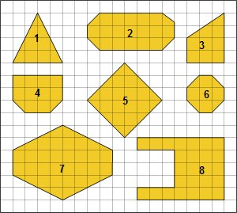

Picture 2 (more strategies/approaches to get an answer can be discussed) [hint: 15/2]:
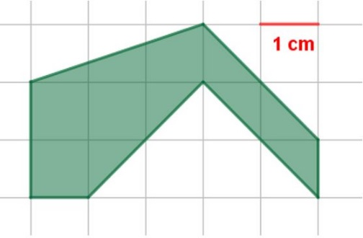

Tool use: Source of Picture 1 and 2 (printed or searchable on mobile devices), paper, pen/pencil

Task 2
Learning objective: Recall the notion of area, connection with summing up squares, estimation

Student activity: Work with picture 3 and guess the area of each shape. Then try to propose how to proceed if you need more precise result/estimate. What could be done to get better approximation?
Picture 3 [hint: approx. 11,78; 21,5]:
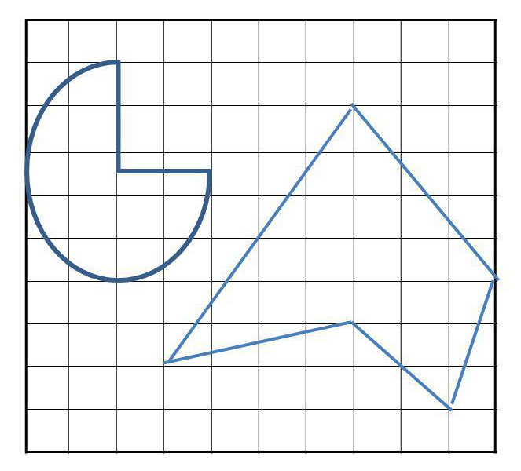

Tool use: Source of Picture 3 (printed or searchable on mobile devices), paper, pen/pencil

Task 3
Learning objective: Understand the limit process of upper and lower Riemann sums
Student activity:
https://grimstad.uia.no/perhh/phh/MatRIC/SimReal/no/SimRealP/AA_sim/AB/SimReal_Mathematics_DiffInt_Int_Integration.htm
First, examine settings, then use the original interval [-7,5] and with the choice of lower rectangles, try to get as precise approximation of the area below the parabola as possible. Who has got the largest value? Then try the same with upper rectangles. Who has got the smallest value? What do we know about the precise value of area of the shape?
Tool use: Mobile devices (tablets)

Task 4
Learning objective: Discover the connection between a result of summation and a sign of the function on a given interval
Student activity: Work with the same simulation and change the function to be sin(x). Observe how large the area below one arc of sin(x) on [0,pi] seems to be. What happens when the interval is extended to [0,2pi]? How is it possible? Deduce the relation between a sign of the function on a subinterval and the value of the integral.
Tool use: Mobile devices (tablets)

Suggestions for use
The simulation can be done also on PC within the web browser with flash player. The link is
https://grimstad.uia.no/perhh/phh/MatRIC/SimReal/no/SimRealP/AA_sim/SimReal_Mathematics_DiffInt_Int.htm

C. Evaluation

Questionnaire – Definite Integral
- What do I understand/imagine under the notion/symbol of the „definite integral“ $\int_{a}^{b}{f\left(x\right)dx}$? What do I expect/imagine that I am able to calculate using the „definite integral“?

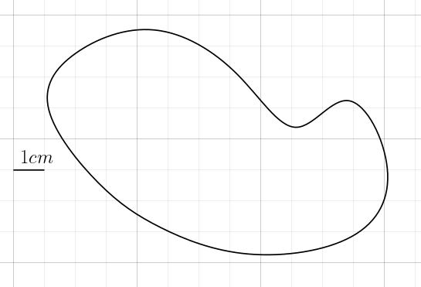
- How would I proceed to find/determine area of the shape inside the curve in the picture?

- What comes to my mind when I see/hear the term „upper/lower sum“?

- In some classes/seminars we worked with touchscreen devices. Rate the level of work with tablets and electronic materials.
¨ Very easy ¨ Easy ¨ Normal ¨ Difficult ¨ Very difficult
- What would help me understand/learn math better?

Questionnaire - experience
Total number of submitted questionnaires: 44
Time period of submission: May - June 2020
Question 1:
41 meaningful (expected) answers (93%)
Question 2 (some answers counted in multiple categories):
- Strategy of summing up squares or similar: 32 (73%)
- Use of the (definite) integration: 13 (30%)
- Another approach: 2 (5%)
- No answer: 4 (9%)
Question 3:
- Correct or close to correct answer: 5 (11%)
- None or wrong answer: 39 (89%)
Question 4 (percentage is calculated from provided answers):
- Choice 1 (Very easy): 19 (46%)
- Choice 2 (Easy): 15 (37%)
- Choice 3 (Normal): 6 (15%)
- Choice 4 (Difficult): 1 (2%)
- Choice 5 (Very difficult): 0
- No answer: 3
Question 5:
Answers to Question 5 have not been relevant to the context of the teaching unit.

Reflection: More than 90% of students have formed successfully an idea of the concept and symbol of a definite integral and what can be calculated using it. About one third of students can combine the idea of definite integral with a practical task. But most would still prefer a less sophisticated method/procedure to calculate/estimate the area of a general shape. According to the results of question 3, students (almost 90%) were unable to understand the underlying concept on which a definite integral is based or did not absorb/recall the terminology used. Next time, we should figure out how to complement existing activities to help the students understand and absorb the concept and notions better/deeper. Concerning the work with tablets, most students can handle digital technology and such activities can be included in teaching design.
Since students were asked to fill in the questionnaire 2-3 months after the lessons/seminars, the results show only long-lasting knowledge. Almost 10 percent of the students did not understand the concepts introduced in the particular seminar. Most of those 10 percent then have not been successful in the final exam. Some of those 10 percent also did not finish the preceding Mathematics 1 (=Calculus 1) course successfully.

